Inspection Data Report
Customer: | Pedro Automation | Subject: | Subject 69
Customer Address: | Beverly Hills | From: | From some person  MAS Inspection Manager
Customer Contact: | me@gmail.com | Company: | Maverick Applied Science, Inc.
Inspection Site: | My house | Maverick Contact Info: | Cell Phone #: (205) 644-2251  Email: jggilbert@mas-mss.com
Customer PO No.: | 69696 | Maverick Job: | 2024312169-1
Customer CCs: | Customer CCs 69 | Maverick CCs: | D. Mikulec; MAS Technical Director
Inspection Date(s): | 9/29/2024 | Report Date: | 10/03/2024
Introduction
We met the people in the plant and it was awful
Entrance Meeting
From some person of Maverick Applied Science, Inc. (MAS) met with me@gmail.com of Pedro Automation upon arriving on site. The goals of the inspection visit were discussed, as well as procedural items such as access to the items and any safety concerns.
Inspection Documents Used During this Surveillance Visit:
- The following drawings were provided and used during the inspection:
  - Equipment Drawing: Temporary Equipment
  - Equipment Drawing: 24242DWG
  - Equipment Drawing: 6767DWG
  - Equipment Drawing: 8989DWG
- The following specifications were used during the inspection:
  - Temporary Spec
  - 08080SPEC
  - 0909SPEC

Inspection Observations:
- Figure 1 shows big tank with steel supports in the foreground.
- Figure 2 shows Unknown material leaking from pipe nozzle or similar connection.
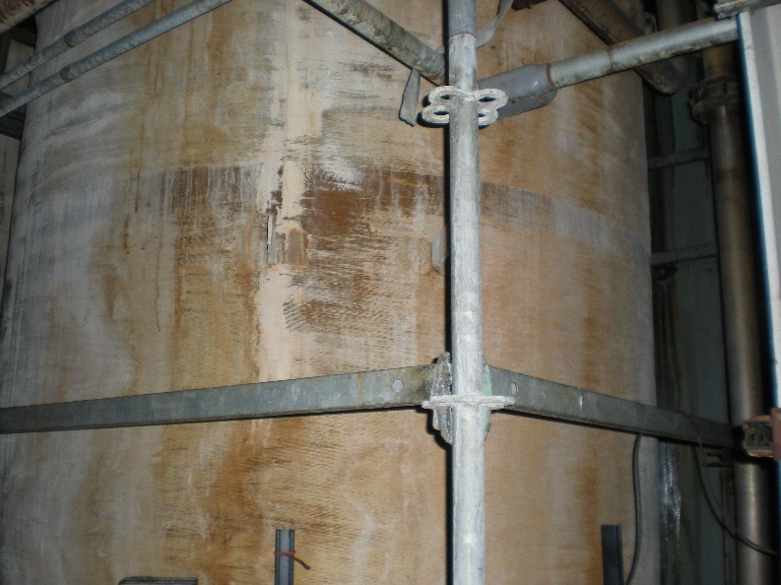  Figure 1: Up-close image of outside of tank or large pipe. | 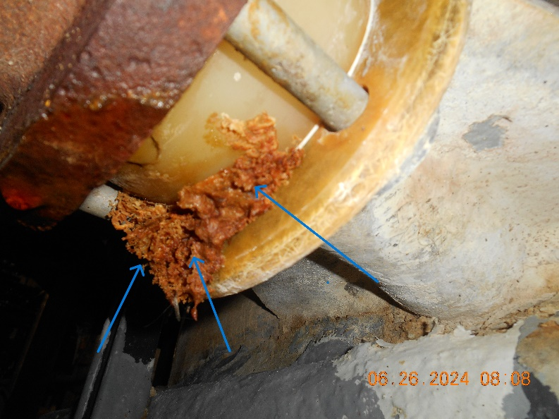  Figure 2: Connection with unknown material.
- Figure 3 shows Corroded tank grounding lug
- Figure 4 shows Delamination of tank
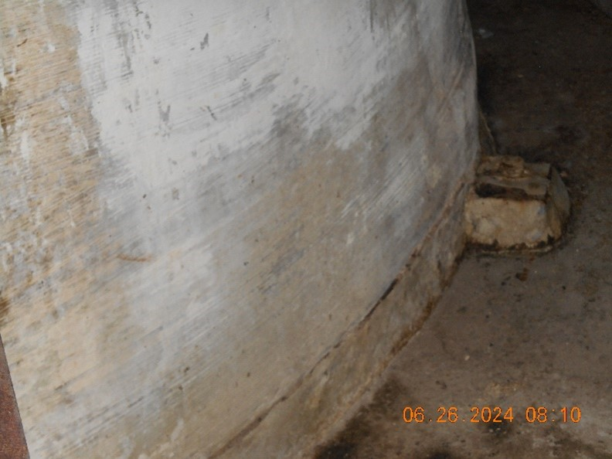  Figure 3: Tank 8383 grounding lug | 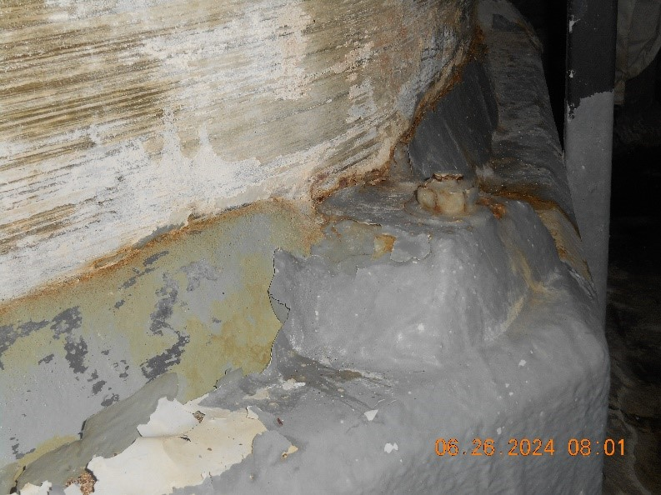  Figure 4: Tank so and so delamination

- Figure 5 shows Delamination of train B

Figure 5: Tank so and so train B delamination
Inspection Conclusions and Recommendations:
This is my fucking conclusion and recommendation.
Respectfully Submitted,
From some person
MAS Inspection Manager
Phone #: 205-644-2251
jggilbert@mas-mss.com

